MongoDB Assignment 4

- Calculate Total Sales for Each Order.

db.orders.aggregate([{$unwind:"$products"},
{$group:{_id:"$_id",
total_sales:{$sum:{$multiply:
["$products.price","$products.quantity"]}}}}])
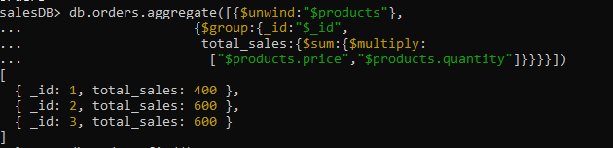
- Calculate Average Order Value for Completed Orders.
db.orders.aggregate([{$match:{status:"completed"}},{$unwind:"$products"},
{$group:{_id:"$_id",
total_sales:{$sum:{$multiply:
["$products.price","$products.quantity"]}}}},
{$group:{_id:null,avg_sale:{$avg:"$total_sales"}}}])
- Find the Maximum Quantity Sold per Product.

db.orders.aggregate([{$unw ind:"$products"},{$group:{_id:"$products.product_id",
max_quantity:{$max:"$products.quantity"}}}])
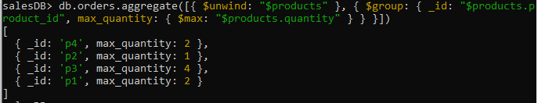
- Find Total Number of Orders for Each Status.
db.orders.aggregate([{$group:{_id:"$status",
no_of_orders:{$sum:1}}}])
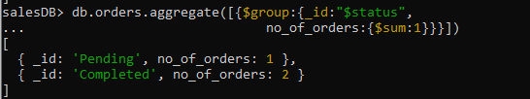

- Calculate Total Quantity of Products Sold Across All Orders.
db.orders.aggregate([{$unwind:"$products"},{$group:{_id:null,
total_quantity:{$sum:"$products.quantity"}}}])

- Get Minimum and Maximum Order Dates.
db.orders.aggregate([{$sort:{"order_date":-1}},
{$group:{_id:null,
max_date:{$first:"$order_date"},
min_date:{$last:"$order_date"}}}])
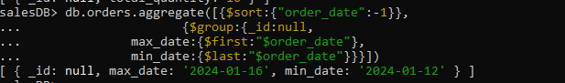

- Find Total Sales for Each Customer.
db.orders.aggregate([{$unwind:"$products"},
{$group:{_id:"$customer_name",
total_sales:{$sum:{$multiply:
["$products.price","$products.quantity"]}}}}])
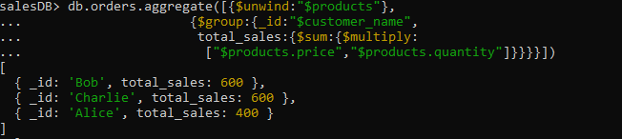
- Calculate the Total Number of Distinct Products Sold.
db.orders.aggregate([{$unwind:"$products"},
{$group:{_id:"$products.product_id"}},
{$group:{_id:null,distinct_products_sold:{$sum:1}}}])
